**Enterprise Resource Planning**

*Of*

**ZAB**

**Training User Manual**

**VERSION 12.0.0**

**Purchase**

**Index**

|  |  |
| --- | --- |
| **About** | **Page No.** |
| * Purchase Order Header | **03** |
| * Purchase Order Detail | **04** |
|  |  |
|  |  |

# purchase ORDER

* Purchase Order Header

|  |  |
| --- | --- |
| **Step 1** | Main Menu (Home Icon) **> Purchase >** PurchaseOrder |
| **Step 2** | Enter Supplier ID () and choose purchase type, Payment term, Currency, Date etc. |
| **Step 3** | Click **Add** |
| **Result** | PO will be created. |

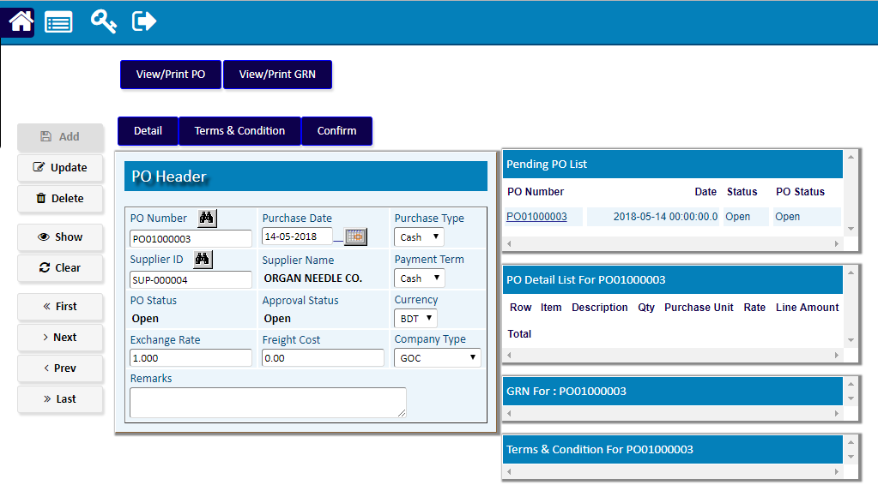

* Purchase Order Detail

|  |  |
| --- | --- |
| **Step 1** | Click Detail |
| **Step 2** | Select the desired item by clicking on the item code from the side list & write qty & price |
| **Step 3** | Click **Add** |
| **Step 4** | Repeat Step 2 and 3 for adding multiple products |
| **Step 5** | Click Complete when done |
| **Result** | PO created. |

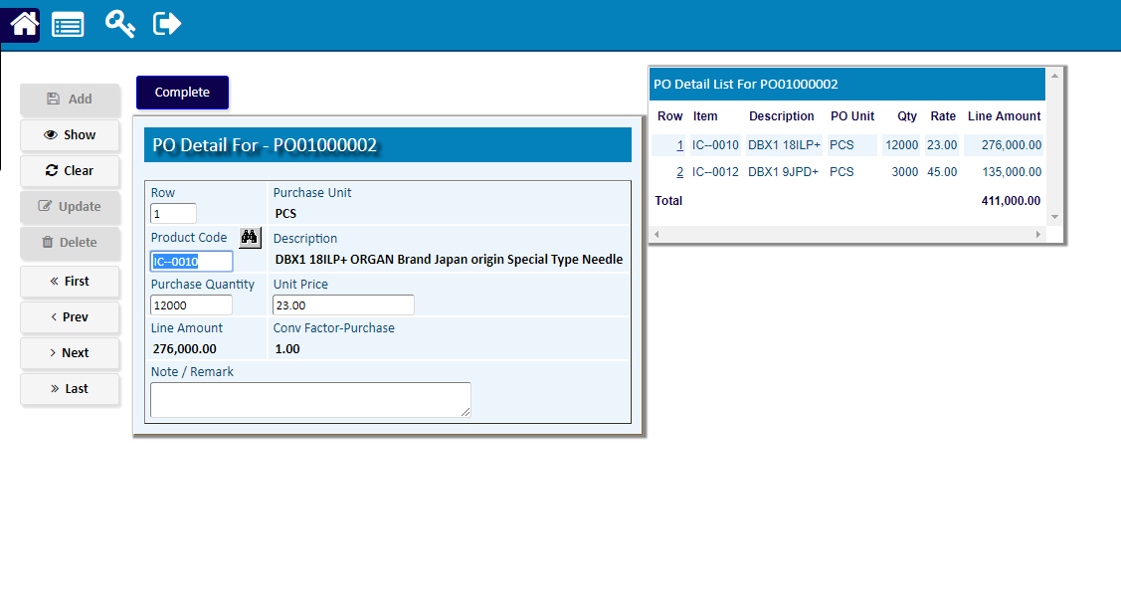

|  |  |
| --- | --- |
| **Step 1** | Click Confirm |
| **Step 2** | The Created PO will be Confirmed |

